Requirement Analysis phase

Date | 4-11-2025
Team ID | NM2025TMID02289
Project Name | Educational Organization Using ServiceNow
Maximum Marks | 4 Marks

Technology Stack Overview

The proposed solution for the Educational Organization leverages ServiceNow as the core platform for digital service management and process automation. Built on the Now Platform, ServiceNow provides a low-code, cloud-based environment that supports modular application development, integration, and workflow orchestration. The system utilizes JavaScript for server-side scripting and AngularJS for client-side interfaces, ensuring dynamic and responsive user experiences. REST and SOAP APIs enable seamless integration with existing academic systems, such as student information systems (SIS), learning management systems (LMS), and HR databases. Additionally, ServiceNow Flow Designer is employed to automate institutional workflows, reducing manual intervention and improving operational efficiency.

Application and Data Layers

The architecture follows a multi-layered structure consisting of the presentation layer, application layer, and data layer. The presentation layer is delivered through the ServiceNow user interface and the Service Portal, offering tailored views for students, faculty, and administrative staff. The application layer handles business logic, request management, and approval workflows through ServiceNow’s Business Rules, Script Includes, and Workflow Engine. The data layer uses the ServiceNow CMDB (Configuration Management Database) and custom tables to store records related to users, assets, courses, and service requests. Data security and integrity are maintained through ServiceNow’s built-in Access Control Lists (ACLs) and Role-Based Access Control (RBAC) mechanisms.

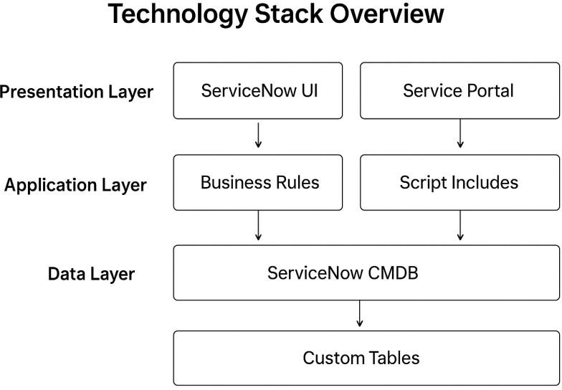

Integration and Communication Architecture

ServiceNow acts as a central integration hub within the educational ecosystem. The system communicates with third-party tools and institutional platforms through IntegrationHub Spokes, REST APIs, and MID Servers. These connectors enable synchronization with systems like Microsoft Teams for faculty collaboration, LDAP or Azure AD for identity management, and external reporting tools for analytics. Event-driven integrations ensure real-time updates and notifications, allowing users to receive automated alerts about service requests, class scheduling, or IT maintenance activities.

Cloud Infrastructure and Deployment

The entire system operates on ServiceNow’s cloud infrastructure, offering high availability, scalability, and compliance with institutional security standards. ServiceNow’s multi- instance architecture isolates each customer environment, ensuring dedicated performance and data privacy. The platform leverages load balancing and data replication across geographically distributed data centers to guarantee reliability and business continuity.

Security and Compliance Framework

Security is integrated into every layer of the architecture. ServiceNow employs TLS encryption, OAuth 2.0, and multi-factor authentication (MFA) to safeguard user interactions. Data access is governed by RBAC, ensuring that students, faculty, and administrators can only view or modify data relevant to their roles. The platform adheres to FERPA, GDPR, and other educational data protection regulations, making it suitable for secure academic environments. Regular audits, compliance dashboards, and activity logs provide transparency and accountability across all institutional processes.

